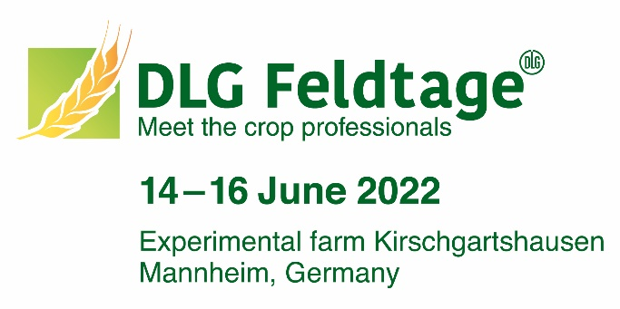
MUSTEREINLADUNG
für den Versand Ihrer Papier-Gutscheine

Adresse Ihres Kunden

2022-05-06
Invitation to DLG-Feldtagen 2022
Dear Mr. Mustermann,
We would like to invite you to DLG-Feldtagen 2022, the meeting point for crop professionals, that will take place on Kirschgartshausen experimental farm in Mannheim from June 14th - 16th, 2022. Visit us at booth X.
Enclosed you will receive a voucher from us, which you can exchange online for a personal admission ticket (valid on one day between 14 – 16 June).
Important: The voucher does not entitle you to admission. You will receive your personal e-Ticket only after successful online registration.
Redeem voucher – this is how it works:
- Visit www.dlg-feldtage.de/registration
- Enter voucher code and register online
- Print e-ticket or save it on your smartphone
Do you have any questions about the registration? You can contact the DLG Feldtage team directly by e-mail ticketing@dlg.org or telephone +49 69 24788-425.
We are looking forward to your visit!
Best regards,

P.S.: All information on redeeming the voucher can also be found on the back of your voucher.

